CONSONANTS

/d/ to dance
/p/ a pen
/G/ a treasure
(on prononce “j”)

/D/ the
/k/ a cat
/v/ to live
/z/ because

/w/ a week
/H/ a shoe
/l/ hello

/m/ Monday
/t/ but
/f/ French

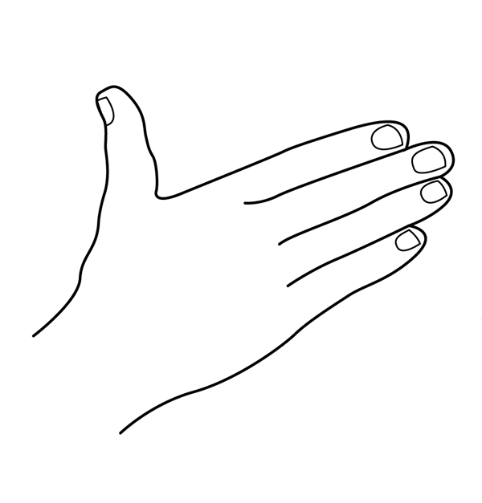

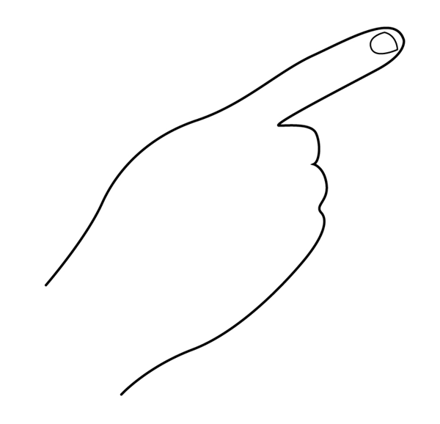
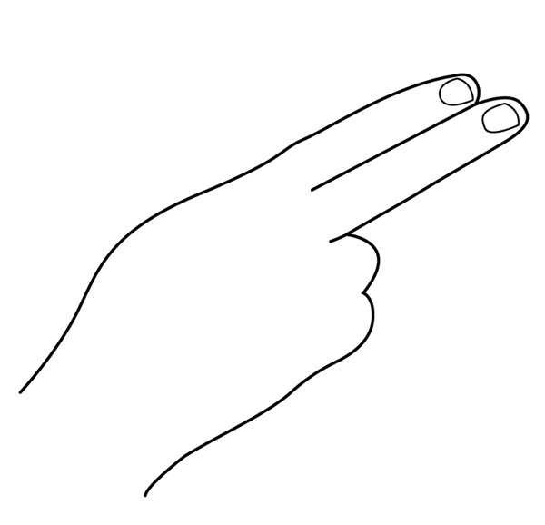

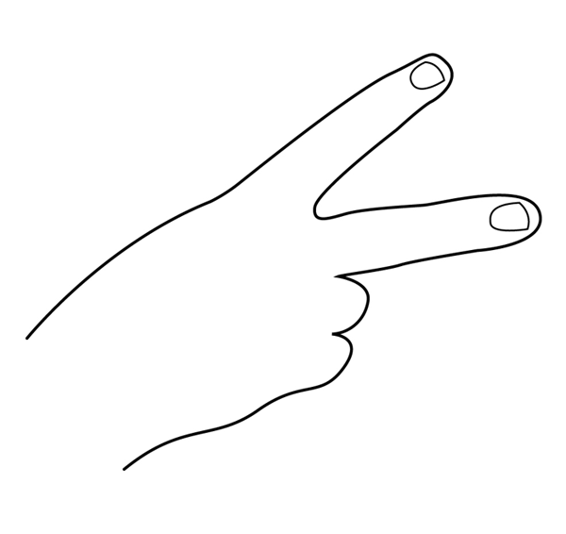
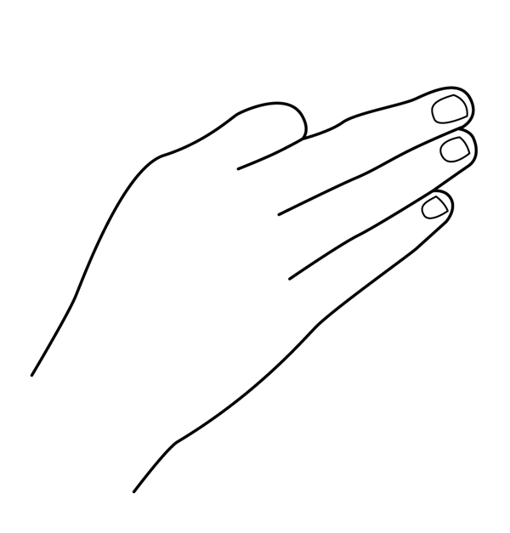
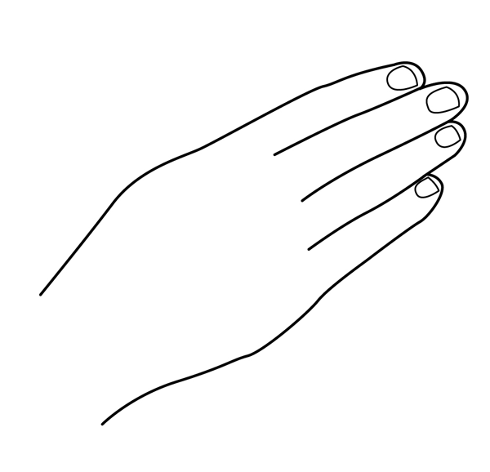
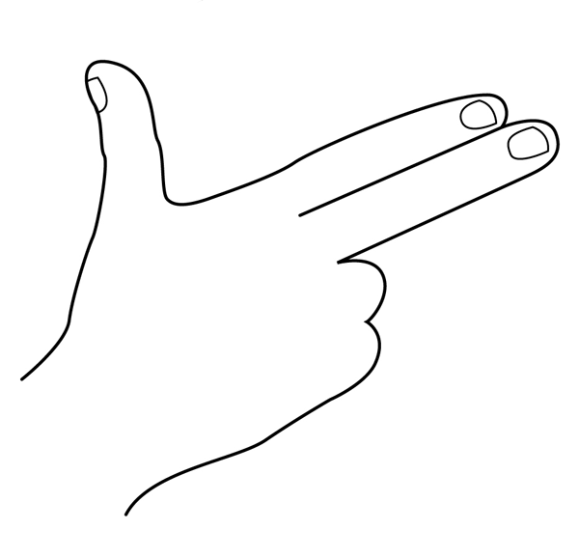

/j/ yes
/C/ a ring
/tH/ a child

/B/ to think
/dG/ January
/g/ good

/b/ black
/n/ a name

/s/ the sea
/r/ red
/h/ happy

