Physical description
HEIGHT
He is ………
Tall | Medium height | Small

HAIR COLOUR
She has got …… hair / Her hair is ………
Blond | 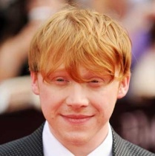  red | Brown
Black | Grey | White

HAIR LENGTH
Short | Medium length | Long

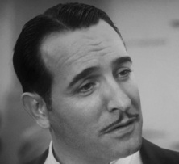  He has got a moustache | 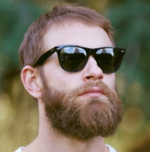  He has got a beard | 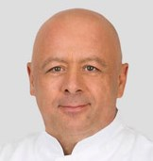  He is bold

EYES COLOUR
I have got ……… eyes / My eyes are ………
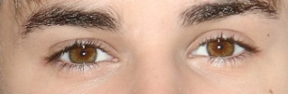  brown | 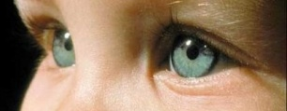  blue | 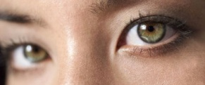  green

