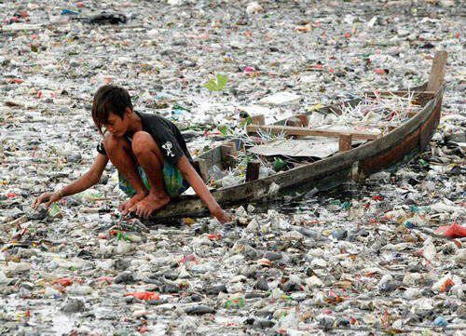
Document 1
Ce que j’observe : ……………………………………………………………………………………… ………………………………………………………………………………………………………………………………………………………………………………………………………………………………………………………………………………………………………………………………………………………………
Ce que j’en pense : …………………………………………………………………………………………………………………………………………………………………… ……………………………………………………………………………………………………………………………………………………………………………………………………………………………………………………………………………………………………………………………………………………………………………………………………………………………………………………………………………………………………………………………………………………………………………………………………………………………………………………………………………………
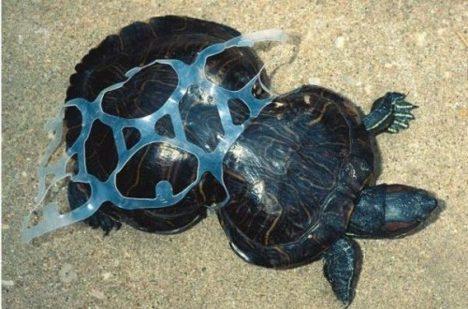
Document 2
Ce que j’observe : ………………………………………………………………… ………………………………………………………………………………………………………………………………………………………………………………………………………………………………………………………………………………………………………………
Ce que j’en pense : ………………………………………………………………………………………………………………………………… ……………………………………………………………………………………………………………………………………………………………………………………………………………………………………………………………………………………………………………………………………………………………………………………………………………………………………………………………………………………………………………………………………………………………………………………………………………………………………………………………………………………

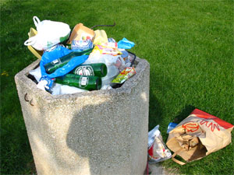
Document 2
Ce que j’observe : …………………………………………………………………………………………… ……………………………………………………………………………………………………………………………………………………………………………………………………………………………………………………………………………………………………………………………………………………………………………………………………………………………………………………………
Ce que j’en pense : ………………………………………………………………………………………………………………………………… ……………………………………………………………………………………………………………………………………………………………………………………………………………………………………………………………………………………………………………………………………………………………………………………………………………………………………………………………………………………………………………………………………………………………………………………………………………………………………………………………………………………
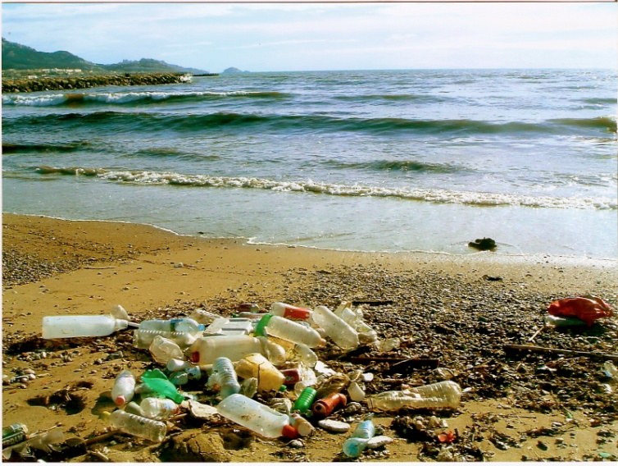
Document 2
Ce que j’observe : …………………………………………………………………………………… ……………………………………………………………………………………………………………………………………………………………………………………………………………………………………………………………………………………………………………………………………………………
Ce que j’en pense : ………………………………………………………………………………………………………………………………… ……………………………………………………………………………………………………………………………………………………………………………………………………………………………………………………………………………………………………………………………………………………………………………………………………………………………………………………………………………………………………………………………………………………………………………………………………………………………………………………………………………………

